New Features
- Early Start IFSP enabled in version 4161 for general deployment to staff.
Bug Fixes
- Employment Information not showing up in IPP after implementation of new Employment tab.
  - This has been resolved in version 4161 and looks like the below. However, the amount of information displayed is NOT dynamic and will not grow or shrink based on the employment status that is in the client’s Employment Tab information.
  - We will be working with RCOC to determine if it is possible to make it dynamic in a future version of the software.
- ID-Notes Created by Tickler not showing up in ID-Notes list and do not show as being validated.
  - Case management staff were not able to click on validated again to validate as well.
  - This has been resolved in version 4161
- Vers 4153 - Manager - Select an SC - Click PDF and it creates a PDF with name of Manager instead of name of SC.
  - This has been fixed in vers 4161 and now the PDF file has the SC’s name instead of the manager.
Known Issues
- Early Start IFSP
  - When completing within the 45 days but over 21 days the IFSP audit page shows that the report is late. We are working with RCOC to fix this in the next version of the software.
  - Type of Report choices does NOT include Periodic. We are working with RCOC to fix this in the next version of the software.
  - Initial Early Start IFSP – Connecting Report in Tickler – Periodic Review -Service Coordinator sees different choices than Manager. Manager has to add tickler entry for SC. SC sees the below screen asking if they want to connect… and can’t get past it. We are aware of the issue and are working with RCOC to fix this in the next version of the software.
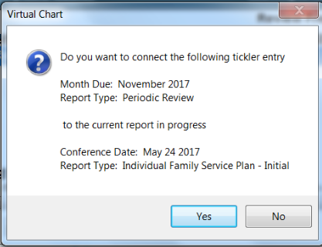
- TSRs – TSRs show in Director Review after Director Signed off. As soon as accounting signs off it does show as “Authorized” as it should. We are working with RCOC to fix this in the next version of the software.
- Resources – Facesheet – Print – Secured PDF. The file is secured/password protected and also cuts off information in the Reports / Status and Authorizations pages on the far right side. We are working with RCOC to fix this in the next version of the software.
- IPP – Report – Employment Information not dynamic. If you have a client who is in a “day program that meets their needs” all of the new employment information field titles still show up but the unfilled out fields show as blank on the report. We are working with RCOC to fix this in the next version of the software.
- SIRs – Follow-up – Shows Gigi Thompson as the “Contact Person Regarding Special Incident:.” We are working with RCOC to fix this in the next version of the software.

