- Face Sheet – FaceSheet
  - Disneyland Ticket Offer (Share Info with Disney)
    - You can select this in the Modify view of the Facesheet
  - Sibling UCI # X 3
    - Does Not auto populated from Sib’s Facesheet
    - We are NOT going to use these at this time.
  - Click to view SSN
    - In the previous version, the SSN was always showing.
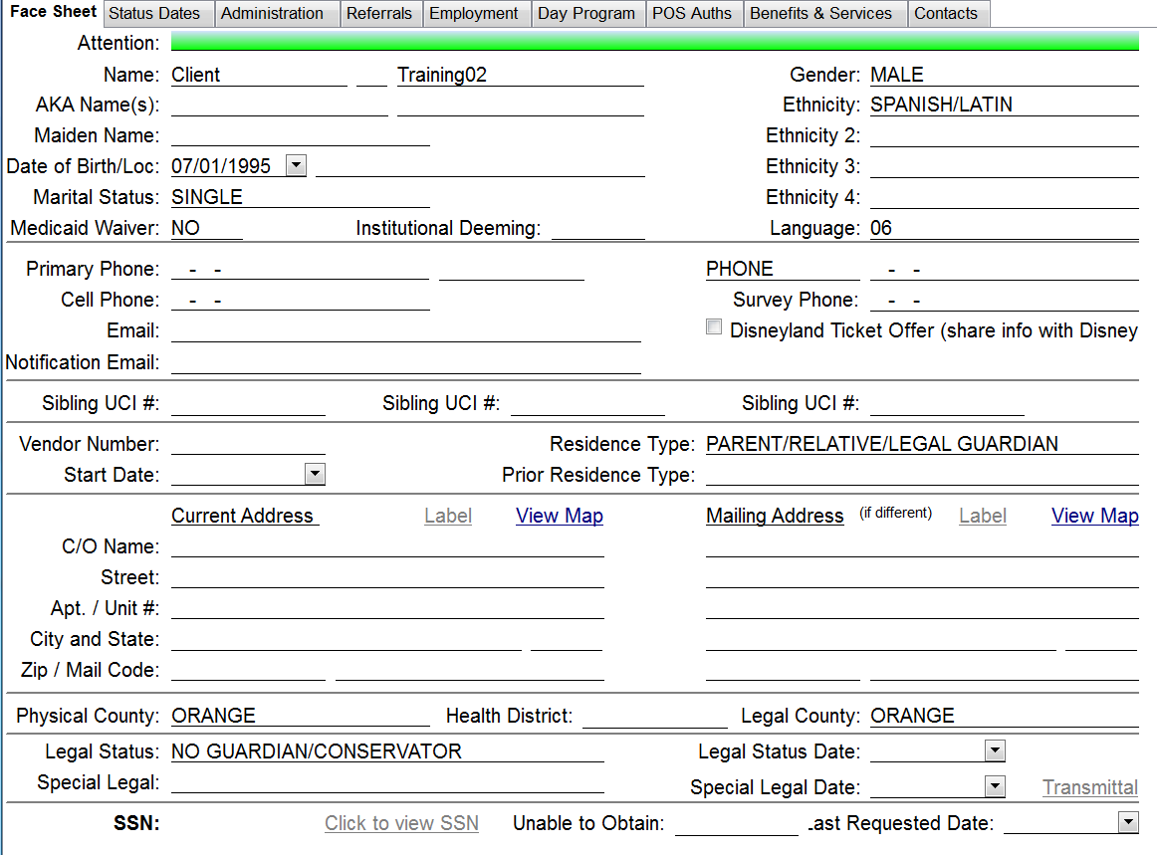

- Facesheet – Status Dates
  - Reason Current 399 Not On File: field
  - This connects to the IPP signature page for RCOC in their Imaging System, and creates a tickler reminder if the IPP signature page isn’t there.
  - Both 399 fields are tied to RCOC’s Imaging system and are NOT USED by HRC.
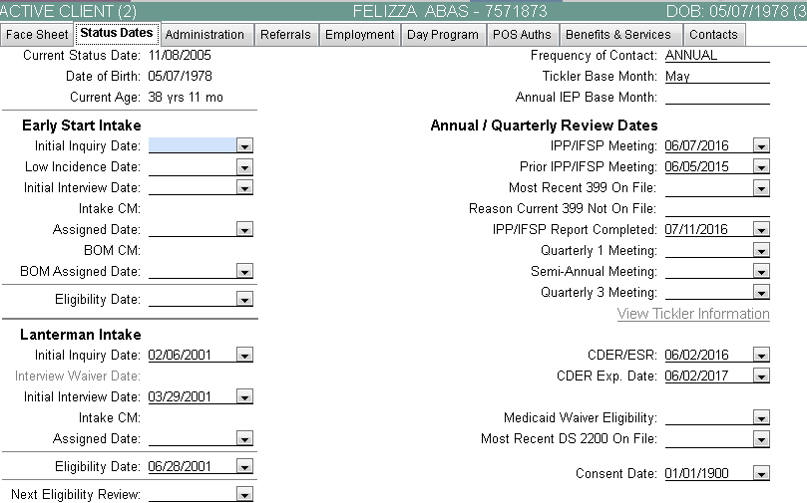
The dropdown is populated with the following list:
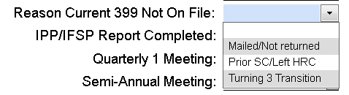

- Contacts
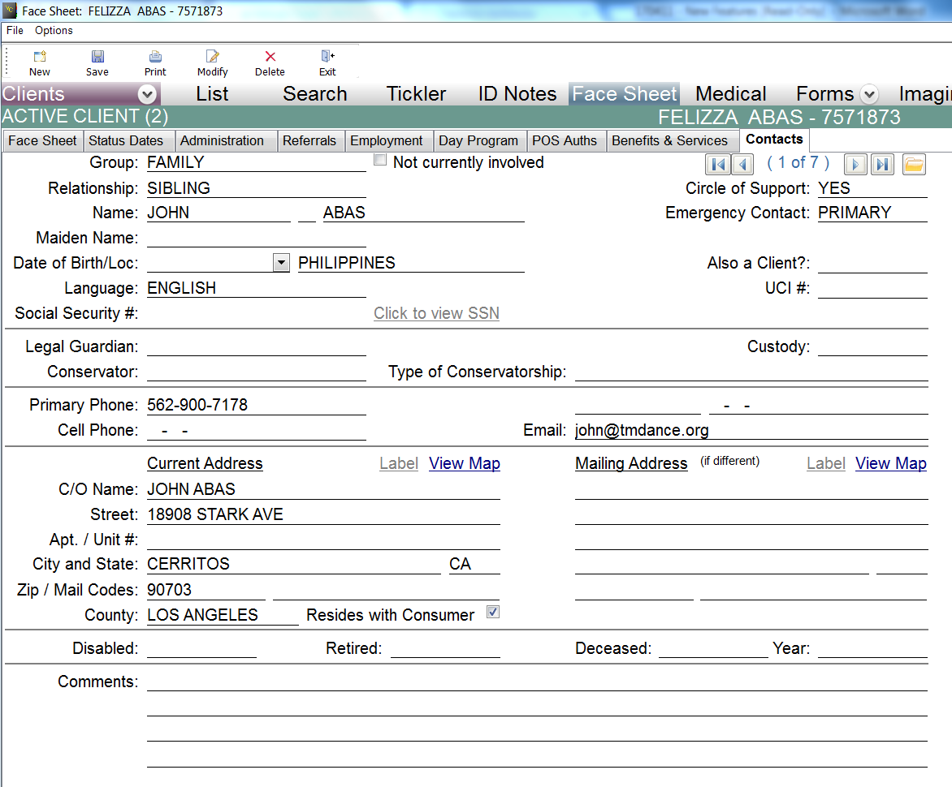
  - Also a client & UCI # - these fields were put in place by RCOC to track if a child client has a parent who is also a client and vice versa. The UCI #: field currently does NOT hyperlink to or reference anywhere else in Virtual Chart, although it may in the future.
    - This was also setup to redact the parent or child client’s info from the other’s IPP.
  - Click to View SSN – Same as Facesheet
  - Legal Guardian, Custody, Conservator, Type of Conservatorship – All were relocated under Social Security # in their own group.

- Forms
  - Renamed IFSP +3 Form to Individual Person-Centered Plan
    - This has been in place for a while but was part of the update.

- ID-Note entry screen
  - View recently entered on-call ID Notes
  - When clicked it pops open a window that shows a list of other people who have entered an ID Note for your client.
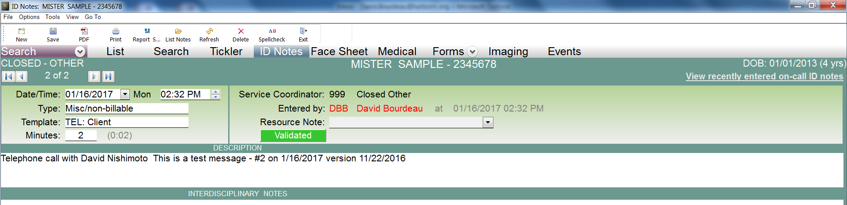
You can print the list but not open the individual ID Notes.
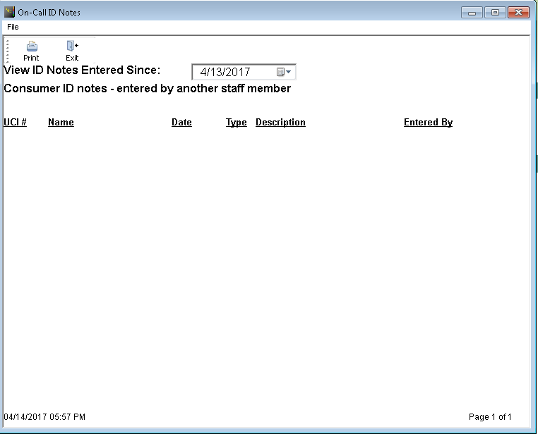
  - ID Notes Find Tool – When you click Find in the tool bar it opens a find tool for ID note that can be used to search for key words in the Interdisciplinary section of the client’s ID Notes.

- IPP
  - INDIVIDUAL FAMILY SERVICE PLAN is finally be renamed to INDIVIDUAL PERSON-CENTERED PLAN in the IPP form.
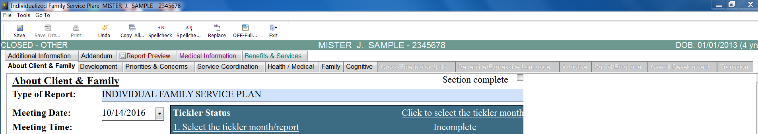

- Employment Tab
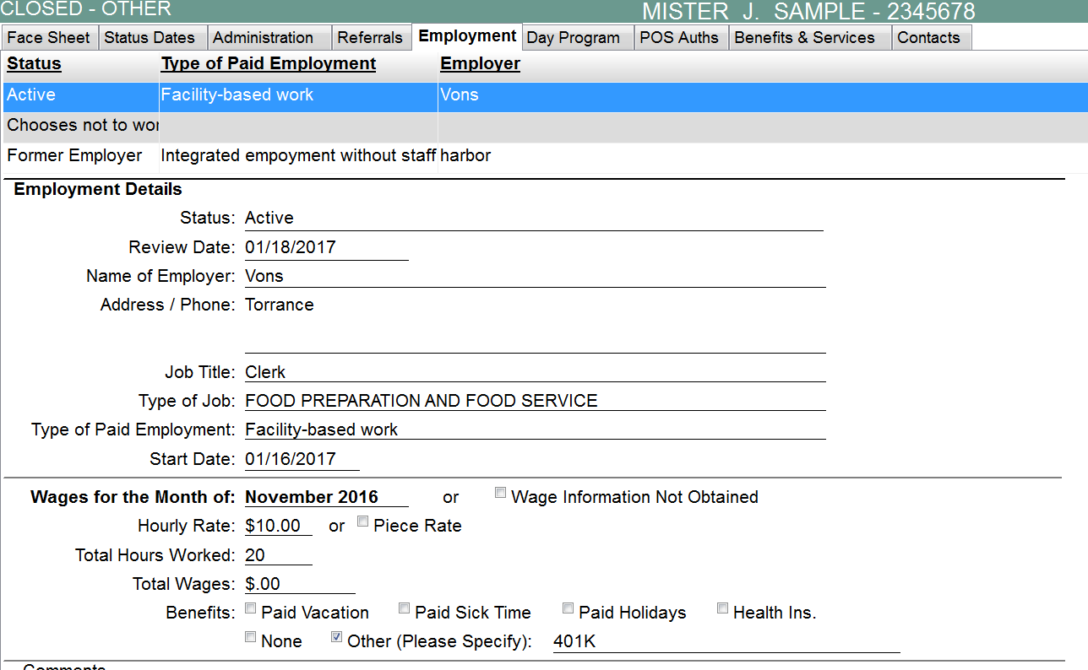
OLD VERSION
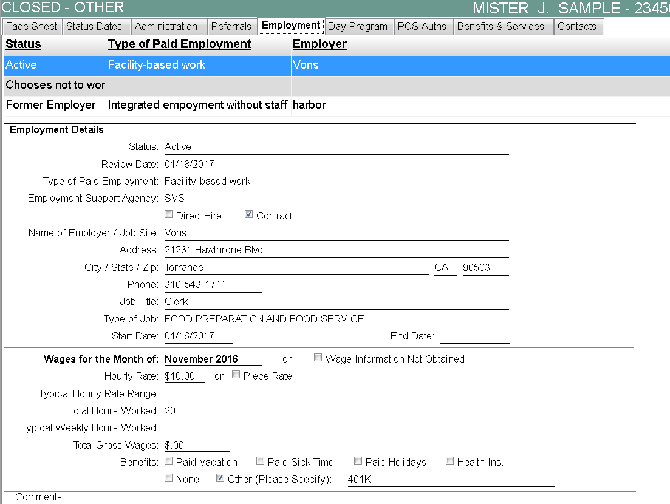
NEW
VERSiON
- The week of 5/22/2017, a new version of VC will be rolled out for the new setup for the employment tab.
- Address / City / State / ZIP / Phone – all have their own field now.
- End Date - field was added to capture when this particular employment has ended for the client.
- Typical hourly Rate Range – Don’t use now will be trained before 5/22
- Typical Weekly Hours Worked - Don’t use now will be trained before 5/22
- Continue to fill out as you have done up until today.

- POS
  - Frequency – Changed the order of the list and added “QUARTER”
    - This field is a mandatory field and we need you to start using this field whenever you do a POS. This is not currently working as a mandatory field in Virtual Chart; however, in the version being deployed at the end of May 2017, this field will be mandatory.
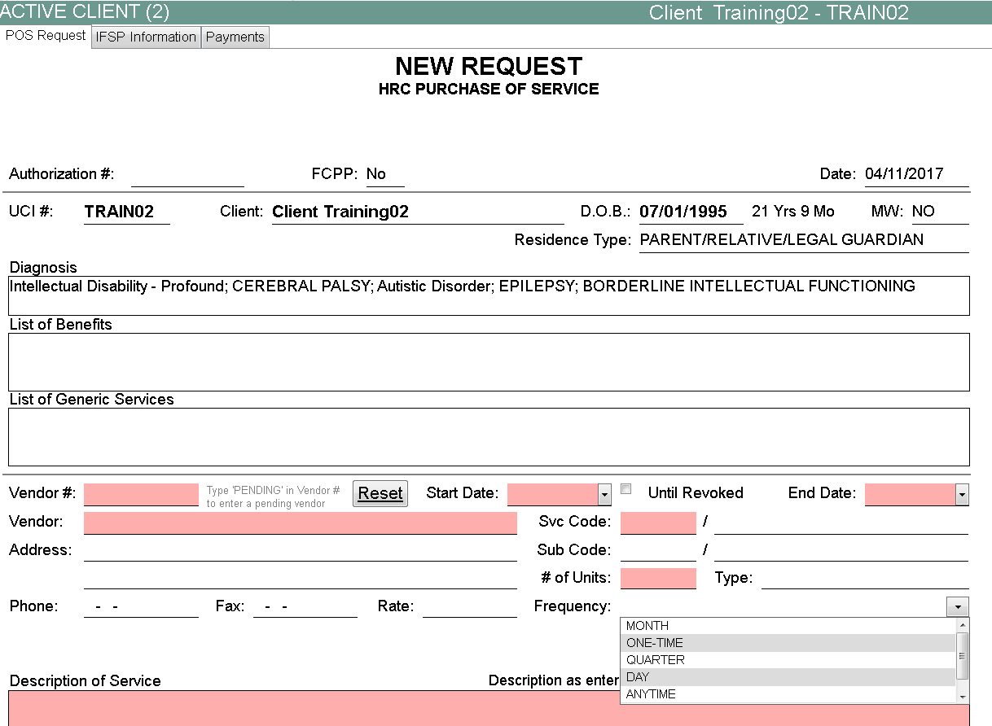
Frequency Options:

MONTH
ONE-TIME
QUARTER
DAY
ANYTIME
WEEK

  - Rejected POS
    - Service Coordinator is now presented with a button to remove CSM signature. This allows the SC to resubmit the POS after modifications specified by the rejecter (Accounting or Director) of the original POS without having to track down the CSM.
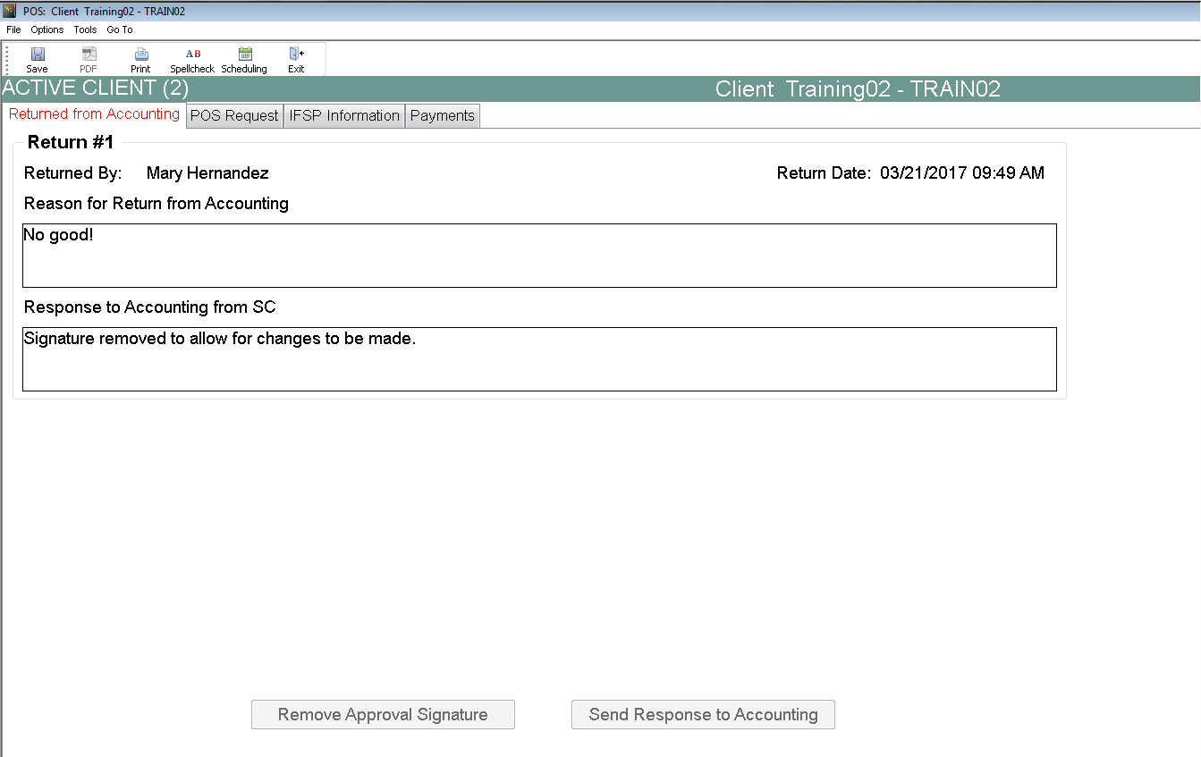
Bugs Fixed:
- POS - Erroneous POS Service and Subcodes – Fiscals would reject or just fix errors due to a database mismatch between the Accounting System and Virtual Chart.
- POS – Director Signoff issue – shows as being in Director queue when it was actually in Accounting Review. This was fixed some time ago with a work around and has been permanently fixed in the coding of the POS module in this version
- Accounting – Vendor Number Pending – Set as Level 1 (CSM signoff) - When a vendor does not exist (bus pass for client) and SC uses Pending as the vendor number. POS now goes to the Director for signoff Level 2.
- Name changes - from IFSP to IPP throughout the Virtual Chart Application has mostly been completed. Most of the references to counselor have been changed to Service Coordinator; most Program Manager references now state the CSM title instead.

Known New Bugs / Features:
- ID Note screen - # of Units changed to Minutes. We are working with RCOC to revert this to Units.
- ID Note Screen – Bottom of screen – View My Dashboard – RCOC purchased a data visualization software to provide a more intuitive view into the individual SC performance by using graphs, charts and other data visualization techniques. We are NOT doing this today, but may look into it for the future.
- Task List – Days of Unclaimed Mileage – Some of you may have this show up on your task list. Please disregard. RCOC created a mileage tracking module for their staff that we are not currently using. We are working with RCOC to remove these tickler items for HRC staff while we are evaluating whether we are going to use this module sometime in the future.
- Early Start POS – IFSP Information Tab – Service Frequency and Duration – If these fields are left blank, will not allow an SC to schedule a POS. The info requested is info that is already located on the POS Request tab. There is no drop down menu for these fields. SCs will need to fill them in for now in order for the POS to be submitted and for those POSs in the CSM queue already, seems like we won't be able to sign off on them until those fields are completed. We are working with RCOC to resolve this issue.
  - This is an Early Start function only – RCOC was hit on an audit for not including this information in the IFSP and this was one of the ways they decided to address the finding.

