New Features
- New Employment tab (see below under Employment tab for additional information)
- POS - Frequency Field in POS is now REQUIRED.
  - Managers will need to fill this in for POSes that were already submitted to your queue and the field not filled out.
- POS - Consolation With: & Consultation Date: fields. These are mandatory field that needs to be fill out when creating a POS.
  - They are at the bottom of the first page where the signatures are.
  - Choices:
    - Behaviorist
    - Dental Coordinator
    - Dietician
    - Nurse
    - OT / PT
    - Pharmacist
    - Psychologist
    - Speech & Language Pathologist
- Added a minute timer in the IFSP/IPP for staff to reference when determining documentation time for ID notes. Located in the upper right hand side of the tab section.
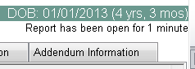
- Allow for staff to modify validated ID notes that have not been bridged to DDS
  - No longer requires managers to send (unbridged) notes back to staff if changes are needed
  - Doing so will reset the validation/verification status for compliance monitoring

- Expanded the amount of text for IPP CDER narrative in the behavior section from 500 to 1500 characters in the database. The fields on the individual forms remain at 700 characters.
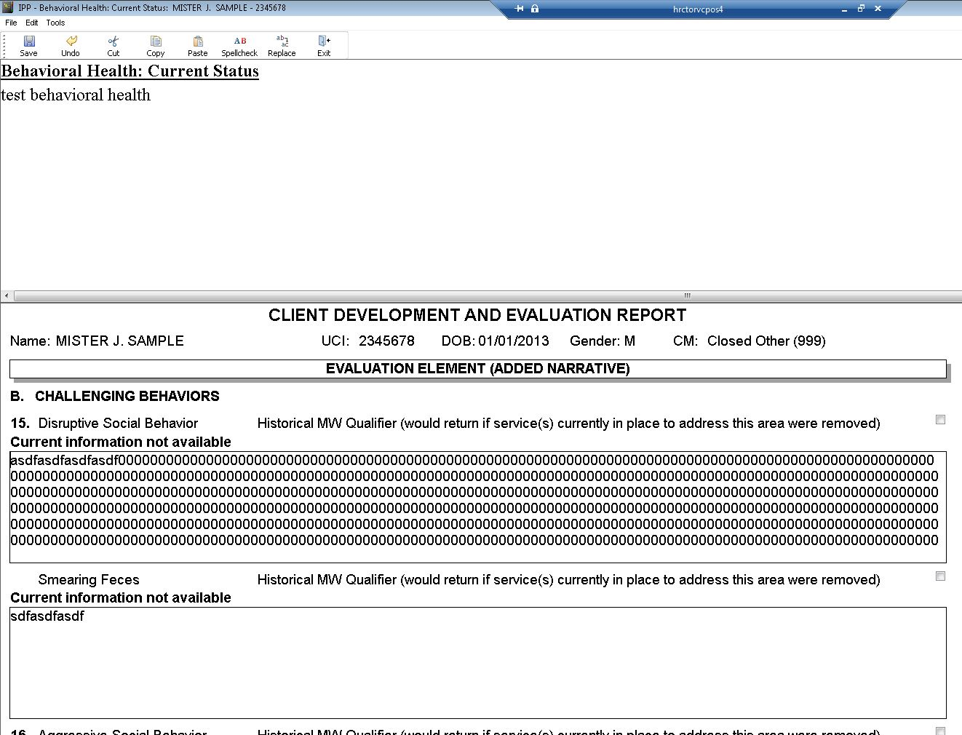
- Fixed an issue with the medication search feature
- Mileage claim enhancements – Does not affect HRC – RCOC only

Bug Fixes
- Vers. 4132 - Forms - POS - IPP Information Tab - Primary / Secondary IFSP Section - This should say IPP for the IPP and IFSP for the Under 3 IFSP – This was fixed in version 8.5.4145
- Vers. 4132 - Forms - POS - POS Form – Tabs - When you create a new POS the IPP Information tab's "title" reverts to IFSP Information. This was fixed in version 8.5.4145.
- Vers. 4132 - Forms - POS - IFSP column should say IPP/IFSP – This was fixed in version 8.5.4145.
- Frequency Field Set to Mandatory in POS – this was set in 4145
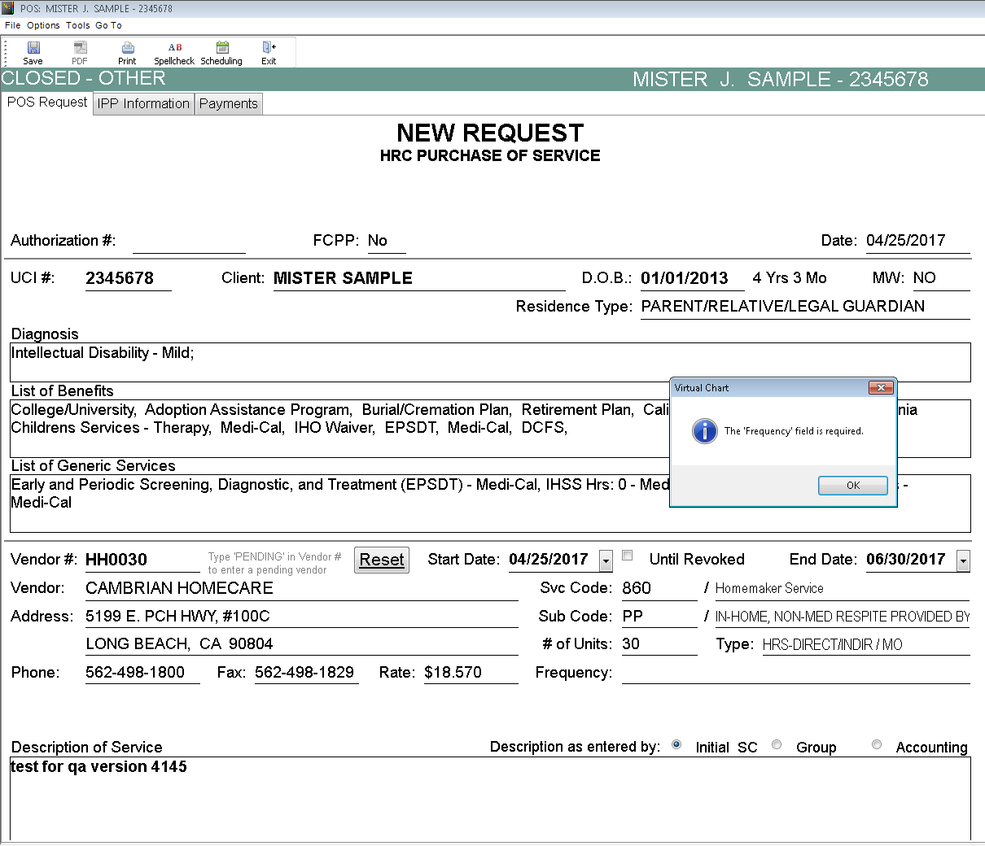
- Vers 4139 - Task List - Days of Unclaimed Mileage - his started showing up on the SC task list after we installed the 8.5.4139 version of Virtual Chart on their computers - This started showing up on the SC task list after we installed the 8.5.4139 version of Virtual Chart on their computers.
- Vers 4139 - ID Note Screen - # of Units changed to Minutes. – was reverted back to units in version 4147.

Employment Tab
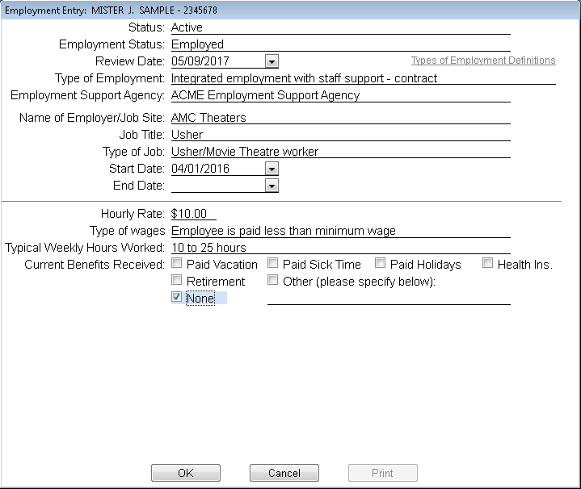
- Status Tab – Changed to have only
  - Active
  - Inactive
- Created Employment Status field and created the below list
  - Attending a day program with partial paid work
  - Attending day program and seeking employment
  - Attending high school / trade school / college
  - Chooses not to work
  - Currently working with a job developer
  - Employed
  - Formerly Employed
  - Health / mental health restrictions
  - In a day program that meets the client’s needs
  - In jail / hospital etc.
  - Independently seeking employment
  - Volunteer
- Type of Paid Employment –
  - removed the word “paid”
  - (drop down with definitions ) Changed the term “ facility based “ to “sheltered workshop”
  - Changed the definitions
  - Add Paid Internship to the drop down menu
- Check Boxes for Direct Hire and contract - Eliminated these two boxes
- Address - Removed this line
- City /State /Zip - Removed this line
- Phone number - Removed this line
- Type of Job ( drop down) - HRC IT - added the following to drop down and rearrange the entire list in alphabetical order
  - deleted “volunteer “ from list
  - Courtesy Clerk/Greeter
  - Usher/Movie Theatre worker
  - Car Porter/Car Washer
  - Grocery store worker
  - Warehouse Worker
  - Data Entry, Scanner, Computer work
  - Shipping and Receiving
  - Animal worker/Animal caretaker
  - Security, loss prevention
  - Heavy Machine operator, Forklift, Truck Driver
  - Media, Graphic, Gaming
- Start and end date –
- Reason Field – appears after selecting an end date
  - Changed employment support agency
  - Found Employment
  - Left for another position
  - No longer interested in seeking employment
  - No longer physically able to work
  - Retired
  - Terminated from position
  - Voluntarily left job
- Wages for the Month and wage information not obtained - Removed this entire line
- Hourly rate or piece rate - Removed the words “or piece rate”
- Typical Hourly rate range - Changed this to “Type of wages”
  - Changed #4 to “non paid volunteer”
  - Deleted “N”
- Total Hours worked - Deleted this line
- Total Gross Wages - deleted this line
- Typical weekly Hours Worked ( drop down) - Removed “ N- Question does not apply”
- Total Gross Wages - deleted this line
- Current Benefits Received
  - add a box for “retirement”
  - Removed comments box completely

Special Incident Reports (SIRs) in Virtual Chart.
Using out of the box for HRC MRQA to enter SIRs into Virtual Chart.
- When MRQA completes the SIR, Virtual Chart automatically sends a Virtual Chart message to the QA Monitor (Provider Relations folks) and to the Service Coordinator assigned to the client.
- The MRQA will also add the CSM and any other pertinent individuals to the distribution when completing the SIR.

